JPMC Placement Experience (CFG hackathon winner)
Batch(2019-2023)

Name : Pranav Padawe
Job Offered : Yes & Accepted
CGPI : 9.4
Criteria : 7CGPA+
Email : 2019pranav.padawe@ves.ac.in
Contact Number : 8850375499

TimeLine:

JPMC RoadShow (Pre-placement Online event - Zoom) | 4, 7 and 8 March 2022
Approximately 4-5 day window was given for attempting Coding Round and Interviews since the emails were sent out in batches.
Coding Round (Hackerrank) | 18-20 March 2022
Interview Round (HireVue) | 26 March - 1 April 2022
Shortlist Result | 09 May 2022
CodeForGood Bootcamps (GitHub, Office Hours, Presentation Skills) - Zoom | 24-26 May 2022 (1 hr sessions every day)
Slack Invites | 25 May 2022
BeMyApp Registration Invites | 08 June 2022
JPMC CodeForGood Hackathon | 11 - 12 June 2022
Final Shortlist Result | 19 July 2022

About Rounds :

Round 1:

Round 1 was a coding test that took place in the 6th semester in the 3rd year. These were Questions related to Strings,array,linked list,stacks and queues.This company doesn't go deep into trees,graphs and dynamic programming questions.So practice as much questions as you can on hackerrank and leetcode before test and then you will good to go for coding test.
If any one wants guidance on how to stairt dsa and increase level gradually can contact me anywhere.Also start practicing DSA questions from the start of 2nd year.

Believe me if you have done practice of more than 200/300 questions and cleared with basic concepts of topics told above then you will easily crack this round.

It had 2 questions for which the choice of language was given to the candidate. I had practiced in C++, so I went ahead with that. It comprised of 2 questions:

Q1: Decimal to binary version
You were given n in decimal form (base 10)and you had to convert it it base 2
https://www.geeksforgeeks.org/program-decimal-binary-conversion/

Q2: This was easy adhoc problem
Question link: https://leetcode.com/discuss/interview-question/1448681/morgan-stanley-assessment-question-identical-distribution

Important Guidelines:

- Your camera has to be switched on at all times during the test.

- Hackerrank has strict plagiarism detection software that makes use of M.O.S.S which can easily identify whether your code is original or not.

Tips for preparation:
Give contest on sites like leetcode,and trying solving atleast first 2 problem.This will help you get ready for your coding round

Round 2:

Link for attempting round 2 was soon mailed to us with instructions to attempt
Platform of interview was Hirevue. If you do some background research about the platform it uses AI so things like your confidence, expressions, voice, lightings play a very major part.

Questions : Questions were same for everyone.

- Tell us about an experience you have had, that you would describe as a learning experience. Tell us about the problem and the outcome.

- Tell us about the specific career goals that you have set for yourself.

Note : There were 2 attempts for each question. Time limit for each question was 1 min 30 secs

I practiced 10-12 times before my final hirevue to get comfortable with the software,so before final recording I would suggest to practice and sit in isolated room and record and see yourself and then analyze it, so that you can give your best in final recording.Don't be nervous and speak with confidence and clear voice Because AI was processing your videos and each and every word should be clear,so that best processing can be done on recordings.

48 Students got shortlisted for Code For Good Hackathon (CFG)
INFT - 23
CMPN - 17
EXTC - 4
ETRX - 2
MCA - 2
Final Round - Code For Good Hackathon

Round 3: Code For Good(CFG)

Because of COVID this round was totally online,this round was a 24 hour hackathon in which 5 NGOs came with their problem statement and we had to give our preferences of the problem statement provided to us and based on that one final statement was given to us.

Timeline

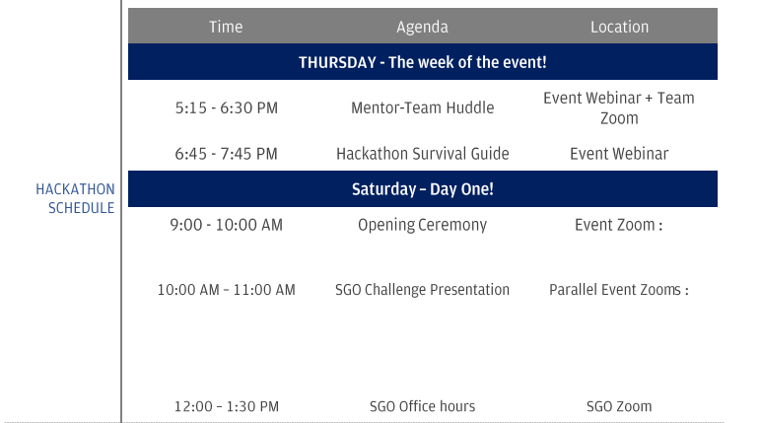
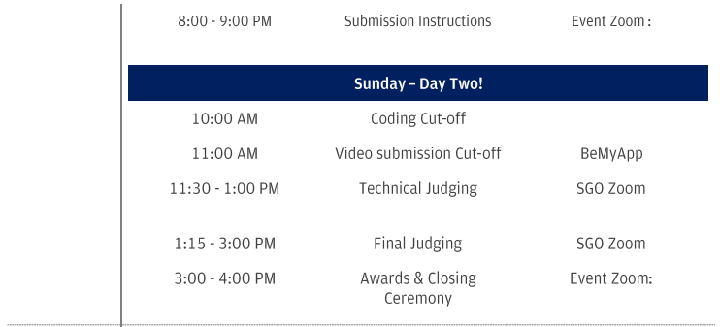
- SGO Assigned -Navasrushti (DBM)
- Team No. 87
- Team Size - 8 (later reduced to 7, since someone dropped out)
- No. of Mentors -2 (One mentor was VP)

- On 9th of june our team mates were released and immediately we found ourselves via linkedin and slack.we made our unofficial whatsapp group where there were no mentors present and then before mentor hurdle we connected on gmeet to get to know ourselves and with what technologies we are familiar with.We chose React for frontend and django for backend,which was decided taking into consideration the skillsets of our teammates.

- We divided our team into two groups,one for front end and other for backend.

- Front consisted of 3 members(React) and backend had 4 members(django),to work more efficiently.

- I was in the frontend team,as I had coding experience in MERN stack.One of member in the frontend team was pretty well versed with techstack,so he did most of the frontend.

- Overall our team coordination was pretty good as well.

- Also don't start code early. Understand their requirements first and clear all doubts regarding statement then discuss with members on what unique thing you are providing which is not existing in current solution and then research on the unique feature which you are providing and then start to code.

- If you are stuck somewhere or facing errors and bugs don't waste time and immediately call SMEs and resolve errors.

- Learn a few popular tech stacks like MERN can come in handy since that’s what a lot of teams end up using. I’d recommend learning React, and Django and working with Databases like MySQL and MongoDB.Also keep authentication code template for login signup page ready before event only and don't waste time on these small things during crucial hours.You’ll also be provided with an EC2 instance that you can connect to, using their proprietary VPN, the credentials to which, will also be provided.

- Also Be comfortable with mentors. They are very frank with us and they really helped us a lot and maintained our spirits high during the whole hackathon.

- As this was a virtual event where we had to sit in one room for more than 30 hours, I felt exhausted because of a lot of load on me. I took a 20-25min break in between to relax my mind which is mandatory. There were 2 one to one mentor sessions in between. Those were like your Hr/Technical interview only.
- In the mentor one to one session,perosnal questions were asked like what are you hobbies,tell me something about your college life,which part of your project you are working on,so on and so worth.

- I took 2 hrs sleep in the night around 5 am to 7 am,as I was feeling very exhausted.

- Meanwhile some members in our team were working on ppt and video presentation.Our project was ready by about 8:30 am.

- And in the remaining time video editing and presentation work was done.

- Later we were shortlisted for second round.

- If your idea gets selected you are selected to the 2nd round.

- In this round 2 teams are selected,and you have to pitch your idea to the respective NGO.

- Our team gave quite a good pitch,and we were declared winner of CFG for our problem statement.(around 4pm)

- So from 8 am to next day 4 pm we were in the meet.

- CFG was a good experience where I got to meet very good coders,and my skills really got levelled up in this 2 days.

Note: Winning or being a finalist is neither necessary nor a guarantee that you will be given an offer by JPMC. So, do not get disheartened, if you cannot get to the finals.Also
There is also a chance of you not getting an offer,so start preparing for the aptitude test of other companies.

Tips:
- Make sure all your teammates are familiar with git.Conduct a unofficial gmeet beforehand with your teammates if they are not,and provide them proper resources.
- No member in your team should be left out,try to involve everyone in the project,if any member is weak then help him to cope up,these are the qualities which you mentor are looking for.
- Remember this is not a competition among your teammates,so dont compete with your teammates,instead coordinate with them well and show your teamwork/leadership skills
- Keep your mentors updated with your status and everyone’s status and give them a holistic view of the progress. This shows that you can take responsibility of the entire team.
- Lastly, the product or the quality of the product you develop has very little to do with getting an offer. What matters is your individual performance and how you bring everything and everyone together.
- Mentor will judge you on your individual contribution and how well you coordinate with you teammates,so try to be polite with your teammates and have good bonding with them.

Tips for winning cfg hackathon
- More than your UI,focus should be on whether your project is solving the problem described by the ngo.
- So focus on adding functionality,which will provide solution to the problem.
- Constantly take input from your mentor.
- Dividing our team into 2 team(front end and backend)really helped to work efficiently

Post cfg:

Everyone receive cfg goodies,and who who got offer letter also receives some additional goodies.
All the member from the winning team receives a IPAD as the prize.

Result:
All the members from our team got the job offer.
Total 41 student got the job offer from our college.

All The Best :)

